Ideation Phase Brainstorm & Idea Prioritization

|  |  |
| --- | --- |
| Date | 12 September 2022 |
| Team ID | PNT2022TMID17703 |
| Project Name | Project - A NOVEL METHOD FOR HANDWRITTEN DIGIT RECOGNITION SYSTEM |
| Maximum Marks | 4 Marks |

Brainstorm & Idea

Step-1: Team Gathering, Collaboration and Select the Problem Statement

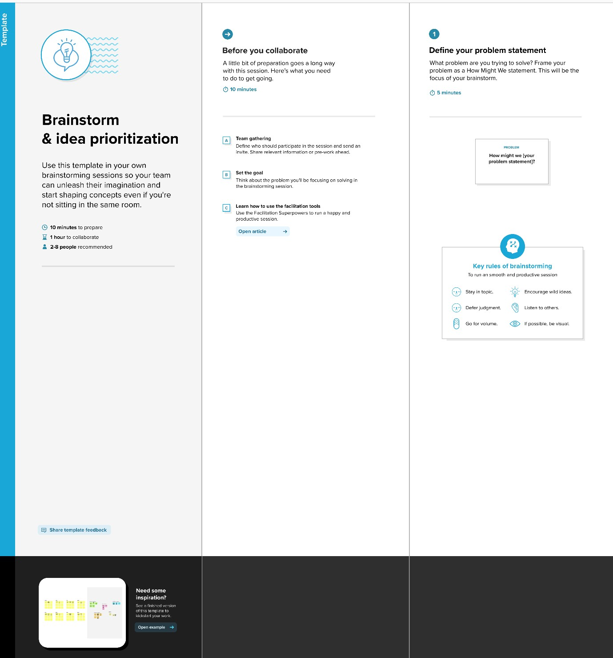

**Step-2: Brainstorm, Idea Listing and Grouping**

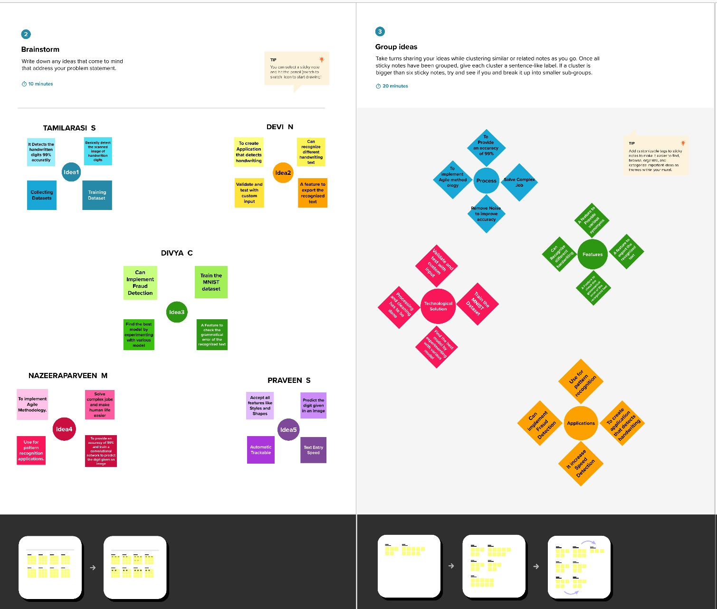

**Step-3: Idea Prioritization**

